

ADVANCED SPREADSHEET PROCESSING USING

MICROSOFT EXCEL 2002-3 (XP)

TRAINING REFERENCE NOTES

COPYRIGHT

Copyright ©2004 by TSkills. This publication, including the student manual, instructor's guide and exercise files, or any part thereof, may not be reproduced or transmitted in any form or by any means, electronic or mechanical, without prior written permission of TSkills.

DISCLAIMER

While TSKILLS Courseware has taken care to ensure the accuracy and quality of these materials, all material is provided without any warranty whatsoever, including, but not limited to, the implied warranties of merchantability or fitness for a particular purpose. Any persons or businesses mentioned in the text of this manual are strictly fictitious. Any resemblances to existing or deceased persons, or existing or defunct businesses, are entirely coincidental.

Product Code: MS EXCEL 2002-3 01.6

TABLE OF CONTENTS

HOW TO USE THIS MANUAL
OUTLINES
AUTOMATIC OUTLINING
MANUAL OUTLINING
COLLAPSING AND EXPANDING LEVELS
DISPLAYING A SPECIFIC LEVEL
PROMOTING/DEMOTING OUTLINE LEVELS
CHANGING OUTLINE SETTINGS
SUPPRESSING THE OUTLINE DISPLAY
CLEARING THE OUTLINE
PIVOT TABLES & PIVOT CHARTS
CREATING A PIVOT TABLE
FORMATTING THE PIVOT TABLE
PIVOT TABLE PAGES
REARRANGING THE DATA FIELDS
WORKING WITH TOTALS
DISPLAYING THE DETAILS FOR A FIELD
CREATING A PIVOT CHART
DISPLAYING/HIDING DATA FIELDS
USING THE GOAL SEEK
THE SCENARIO MANAGER
CREATING A SCENARIO
DISPLAYING A SCENARIO
EDITING A SCENARIO
MERGING SCENARIOS
CREATING SCENARIO SUMMARY REPORTS
DELETING A SCENARIO
ADDING CELL COMMENTS
REPOSITIONING/SIZING THE COMMENT BOX
EDITING A COMMENT
DELETING A COMMENT
ADDING AN OUTLOOK TASK
WORKING WITH SHARED FILES
SHARING A WORKBOOK
UPDATING A SHARED WORKBOOK
REVIEWING WORKBOOKS
REQUESTING A REVIEW
REPLYING TO A REVIEW REQUEST
MERGING REVIEWED WORKBOOKS
ENDING THE REVIEW PROCESS
SENDING A WORKBOOK TO ANOTHER USER
SELECTING MULTIPLE ADDRESSES
CONSOLIDATING DATA

HOW TO USE THIS MANUAL

This manual was designed to be used as a reference. It covers each topic discussed in class in the order they will be introduced. This is not a step-by-step tutorial. Our feeling is that you did not pay to have someone stand in front of class and read you something that you could do on your own. Through our own classroom experience we have discovered that students don't read detailed descriptions and that lengthy text is ignored. They prefer to explore and try things out.

In typical tutorials, students often get lost following rote procedures and get caught in error conditions from which they can't back out of. Besides, once students leave class, they just want something where they can look up a subject quickly without having to read through an entire tutorial.

Our design ensures that each course is stimulating and customized yet covers the outlined objectives. The left page of your manual is designed for note-taking. That way, you won't have to switch between your notebook and a manual whenever you need to look up how to perform an operation.

Keys and commands that you need to press are displayed as icons such as E or Z.

Each topic starts on a new page, making things easy to find and follow. In addition, topics covering actual commands are divided into two parts, USAGE and MENU. Excel has two methods for accessing its commands: Either through the keyboard using a combination of the function keys and shortcuts, or through using the mouse by accessing the menu and tool bar. Not knowing which you would prefer, this book has been written emphasizing the menu and tool bar. Any keyboard shortcuts will, however, be included within the TIP boxes while mouse shortcuts will always include the MOUSE icon beside it.

The next page shows how a typical topic will be discussed and each part found in the book.
THE TOPIC TITLE WILL BE ON TOP

USAGE: This part explains what the command is used for, how it works and other miscellaneous information.

This section lists the keystrokes or function keys the user may press as a shortcut for performing the current command.
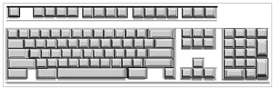

MENU: This section lists the menu choices the user must select in order to perform the command through the menu system.

Since Excel was written to be used interactively with a mouse, there will be many tools that will be mentioned which can be used in place of the menu or keyboard.


NOTE: This box will mention things to watch out for. The symbol in the left column always indicates an important note to remember.


TIP: This box will let you in on a little secret or shortcut. The pointing hand always indicates a "TIP".




● Outlines
● Pivot Tables

OUTLINES

USAGE: Spreadsheets are typically created in a hierarchical manner, meaning that categories can be broken down into sub-categories. For example, you might have a major expense category called "Utilities" which actually consists of water, electric, gas, and so on. Typically, managers are only interested in seeing the overall picture rather than each small detail.

With an outline, you could hide the details (sub-categories) and print only the major categories. Outlines allow you to provide as much detail as you want yet also provide the capability of printing at any level.

Without having created an outline, you would have to manually hide each set of columns/rows you did not want to print. With an outline, you can change the level of detail with one keystroke.

The following example shows various regions broken down by city:
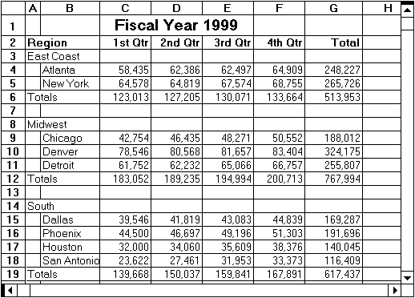

Also, outlining provides an easy way of quickly graphing various levels by simply changing the level of detail.

Excel can handle up to 8 levels of detail for both columns and rows.

AUTOMATIC OUTLINING

Excel can automatically outline a selected block of cells within a worksheet - as long as formulas are present. Automatic outlining relies solely on formulas and the direction of their reference.

When creating an automatic outline, the program looks for references in formulas to blocks of cells directly adjacent to the cell containing the formula, especially in cells to the left or above the cell. Excel determines outline levels based on summary formulas.

For example, if cell B10 contains a formula which adds the contents of cells B2 through B9, Excel assumes cells B2 through B9 would be one level beneath cell B10 - since B10 summarizes B2 through B9.

To create an outline, follow these simple steps:

❶ Highlight the cells you wish to base the outline on.

❷ Access the following menu:
MENU:
data
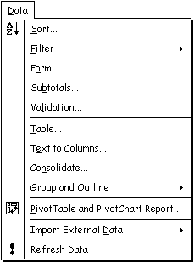
group and Outline ➢

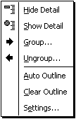
❸ Select auto Outline from the sub-menu.
Excel will convert the worksheet into an outline structure, as shown in the diagram below:
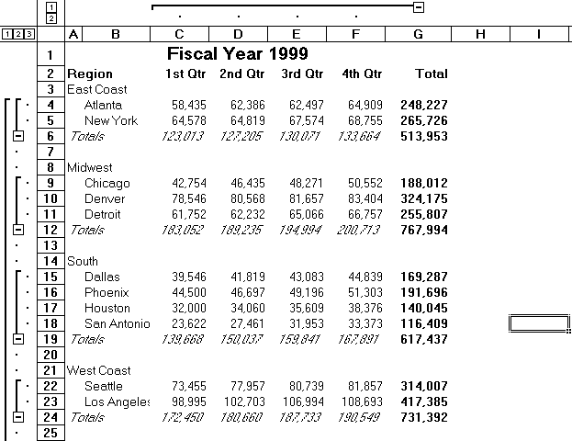

MANUAL OUTLINING

There may be times when your data is not organized in a manner that will allow Excel to automatically create an outline from it.

For example, you may have groups of cities that you would like to break down into regions of the country (e.g., San Francisco, Los Angeles and San Diego would all belong to the west coast region). If the sheet you are working with, however, does not contain formulas summarizing these cities, Excel will not know where to make the breaks between outline levels. In this case, you will have to manually create the outline.

When creating an outline manually, you need to group the data yourself. Begin by selecting the rows of detail (e.g., the actual cities beneath the heading West Coast) and then press the following keys:

A+S+R
If you prefer accessing the menu:
MENU:
data
group and Outline ➢

Select group... from the sub-menu.

Continue doing this for each level you wish to create.

NOTE: If you had selected only the cells containing the detail information rather than the entire row/column(s), Excel would display a dialog box asking you to select where the information is stored (columns or rows).


UNGROUPING A LEVEL

If you select the wrong data to be grouped, Excel allows you to ungroup the information.

Before continuing, select the row/column(s) you wish to ungroup:

A+S+Q

If you prefer accessing the menu:
MENU:
data
group and Outline ➢

Select ungroup... from the sub-menu.

Continue doing this for each level you wish to ungroup.

NOTE: If you had selected only the cells containing the detail information rather than the entire row/column(s), Excel would display a dialog box asking you to select where the information is stored (columns or rows).

COLLAPSING AND EXPANDING LEVELS

When you create an outline, the areas above and to the left of your worksheet are marked by one or more brackets (called Level Bars) and end with a minus-sign  (referred to as Collapse Buttons).

Level bars define a block of cells within a single level. The collapse buttons appear above or to the left of each level's summary cell.

To collapse a level, click on the minus-sign. The minus sign will be replaced with a plus sign called the expand button.

Click on this button to have the outline level expanded back to its original format.

DISPLAYING A SPECIFIC LEVEL

Once you choose to display your worksheet as an outline, you will see two sets of buttons (called Level Buttons) located above the worksheet (for columns) or to the left (for rows).

Click on the button to display an outline level.

PROMOTING/DEMOTING OUTLINE LEVELS

If you have turned the outline mode on and decide that a level needs to be changed, it is possible for you to make the necessary adjustments to the outline by promoting/demoting levels yourself.

Begin by selecting the row/column(s) to be promoted or demoted:

A+S+R Promotes the selected row/column(s).
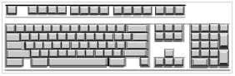

A+S+Q Demotes the currently select row/column(s).

CHANGING OUTLINE SETTINGS

You can specify whether predefined styles will be applied to your outline. These styles include formatting codes which help to determine the outline levels.

To do so, follow these steps:

❶ Access the following menu:
MENU:
data
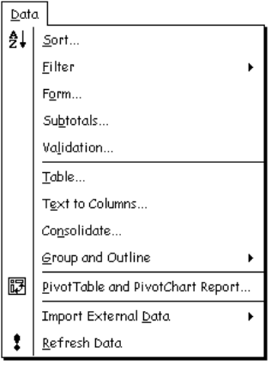
group and Outline ➢

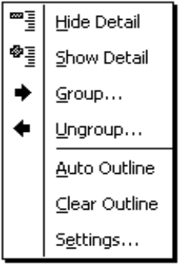
❷ Select Settings... from the sub-menu.

The following dialog box will be displayed:

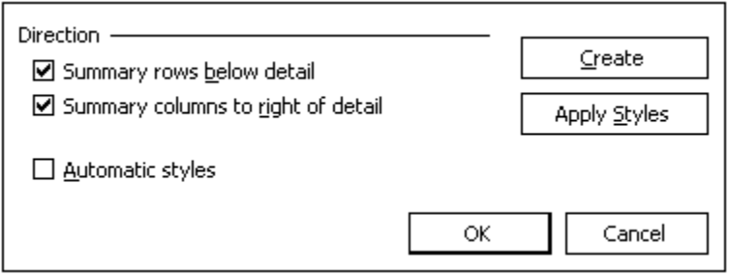
(OPTIONAL) ❸ Check the box labeled Summary rows below detail to define how row levels should be determined.

(OPTIONAL) ❹ Check the box labeled Summary columns to right of detail to define how column levels should be determined.

(OPTIONAL) ❺ Check the box labeled Automatic styles to specify whether Excel will format the outline as based on predefined styles. These styles will be applied to the entire row or column of the outline.

(OPTIONAL) ❻ Click on  to assign outline levels based on formulas within the current sheet. If the Automatic Styles box is checked, Excel applies built-in cell styles to the outline.

(OPTIONAL) ❼ Click on 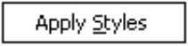 to apply both row and column level styles to the currently selected portion of the worksheet.

❽ Once outline setting have been made, click on .

SUPPRESSING THE OUTLINE DISPLAY

If you decide you would prefer not to display the outline symbols shown above and to the left of the columns, you can choose to remove them from the display by accessing the following menu:
MENU:
tools
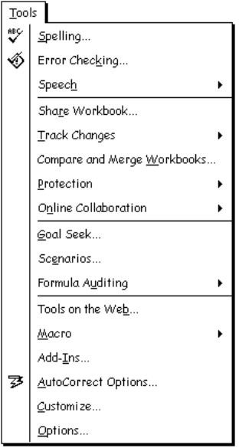
options...

Be sure to select the View tab, as shown below:

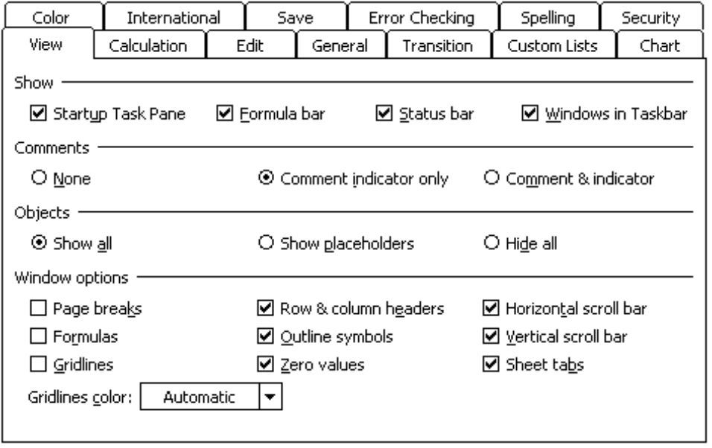
Take the check (☑) out of the Outline symbols box to remove the outline symbols from the screen and then click on .

NOTE: The outline definition itself has not been deleted so anytime you want to view the outline, simply return to this dialog box and put the check (☑) back in the Outline symbols box.


CLEARING THE OUTLINE

You may want to completely clear the outline definition. This not only removes the outline symbols but the outline definition as well.

To clear an existing outline, access the following menu:
MENU:
data
group and Outline ➢

Select clear Outline from the sub-menu.

The outline symbols and definition should now have been cleared.

NOTE: Should you want to view this worksheet as an outline at a later time, you would need to go through the steps of creating the outline again.


PRACTICE EXERCISE

Instructions: ❶ Open the file REGIONAL.

❷ Block the actual data on the worksheet (Not the title!) Turn the automatic outline display on.

❸ Collapse the outline so that only the actual regions and totals are displayed (not the cities).

❹ Print or preview the file while in this display mode.

❺ When you are done, be sure to expand the outline so that all items are displayed and turn the outline symbols off from view.

PIVOT TABLES & PIVOT CHARTS

USAGE: A Pivot Table is used as an interactive worksheet table that allows you to quickly summarize large amounts of data using the format and calculation method specified by you. The name refers to the table's ability to rotate rows and column headings to access different views or perspectives of your data.

When creating a pivot table, you will be asked to specify the data to be used as row fields, column fields and page fields.

Fields are categories of data such as years or regions. These data categories can be separated by rows, columns or pages. If, for example, you were creating a sales report for the past five years, you might want to start each new year on a separate page.

These fields can be further broken down into items, which are essentially sub-categories. For example, you may have a field labeled Year which can be grouped by each year. Each individual year is an item within the field called Year.

The data to be summarized (such as sales) is referred to as the data area. It typically consists of numeric values but can also consist of text.

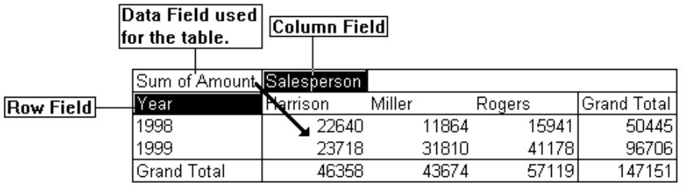
The arrangement of the fields within the table is referred to as the layout. You can change the layout by dragging fields to "pivot" the table to a different perspective for viewing purposes.

Like an automatic outline, the Pivot Table is based on formulas, such as the SUM or AVERAGE function. Excel automatically uses the SUM function for numeric data and the Count function for text.

CREATING A PIVOT TABLE

Since Excel comes with a PivotTable Wizard, creating the table itself is very little work as it guides you through each of the steps required in determining the source and location of the data, the table's layout, and where the table should be placed.

To create a pivot table, follow the steps outlined below:

❶ Access the following menu:
MENU:
data
pivot Table and PivotChart Report...

There are three steps necessary when creating a pivot table.

Each step includes buttons to move through the process.

For example,  moves to the previous screen to make a correction/change while 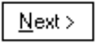 moves to the next step.

Click on 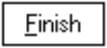 only when everything is complete.
Step 1 is used to specify the source for the pivot table, as shown in the diagram below:

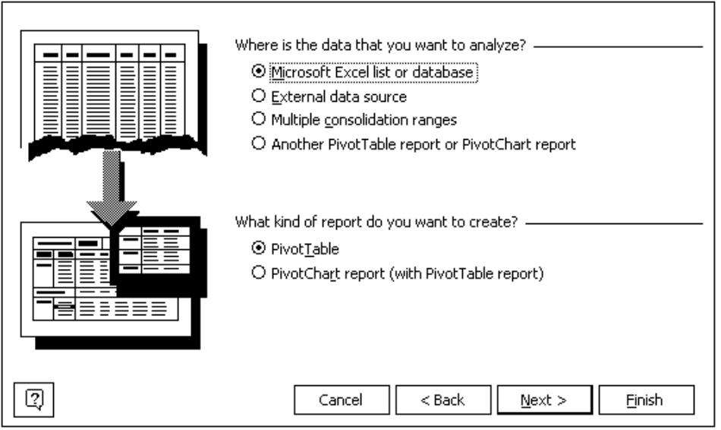
You can use data from any of the following sources:

➢ Any list, database or range containing column labels.

➢ Data from external database applications such as Access.

➢ A combination of ranges. However, they must contain both row and column labels.

➢ An existing pivot table.

This step is also used to specify what kind of report (PivotTable or PivotChart) you wish to create. Although you can create a pivot chart from here, pivot charts must be linked to a pivot table so you will end up first creating a pivot table anyway.

❷ Select PivotTable as the type of report you wish to create.

❸ Click on to move to the next step.
Step 2 is used to identify the exact location of the data, as shown in the diagram below:
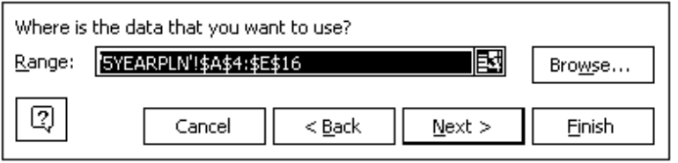

❹ Using the box provided, select the data to be included in the table. Excel will try to guess the range, but you can always highlight or type the range yourself.

If you click on the  button, the box will be temporarily set aside and you will be taken back to the worksheet where you can select the range to be used for the table.

Once the range has been selected, re-activate the wizard by clicking on  (located in the right corner of the Pivot Table Wizard title bar).

If the data is contained within a different file, use the 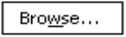 button to select the file.

❺ Click on to move to the next step.
Step 3 is used to determine where the pivot table will appear, as shown in the diagram below:

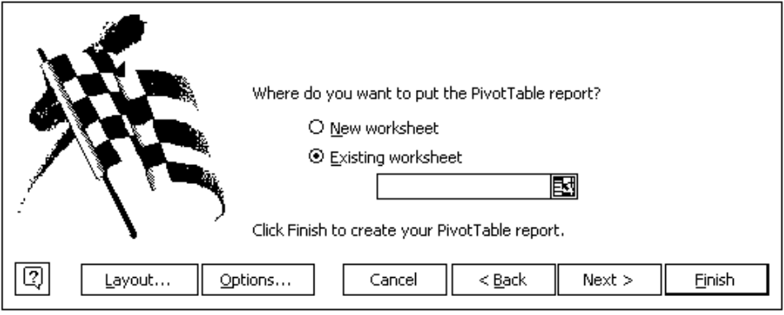
❻ Specify the upper-left cell of the pivot table. Be sure that the area you specify will not overwrite existing data.

❼ Click on the 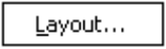 button (which is located along the bottom of the dialog box) to specify the layout of the pivot table, as shown in the diagram below:

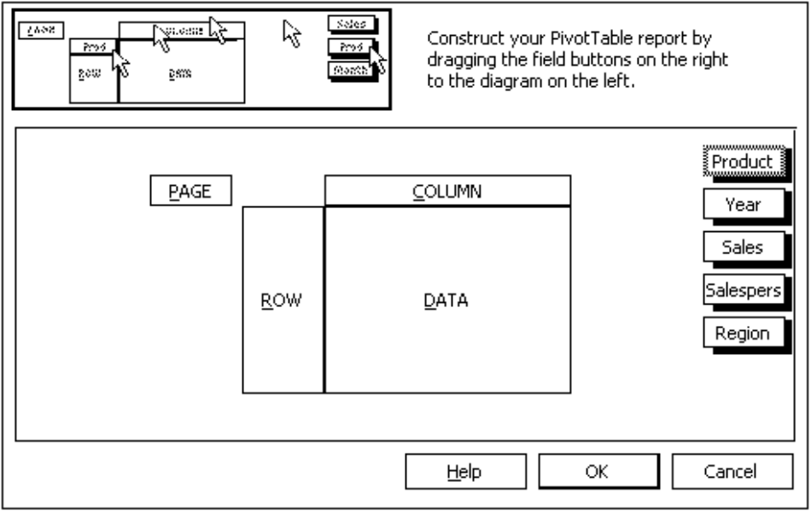
❽ From within the “Layout” dialog box, drag the fields to use as row field and column field labels into the sections labeled "ROW" and "COLUMN".

You will also need to drag the fields whose data you wish to summarize into the area labeled "DATA". For example, you could create a table that would sum the sales amount by year first. Each year’s sales could then be sub-divided by the item sold. The columns would break the sales down according to the salesperson.

Click on to return to the third step of the wizard.

❾ Click on  (located along the bottom of the dialog box in Step 3) to access another dialog box where you can name the table, add totals to columns and/or rows, save the original source data with the table (as opposed to refreshing the table each time the worksheet is opened), and to automatically format.
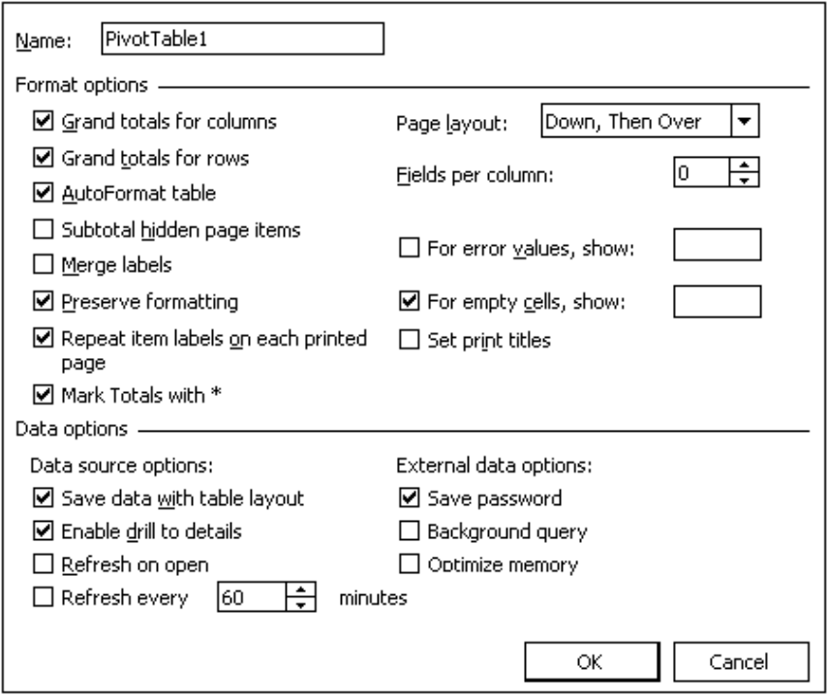
When done, click to return to the wizard.
❿ Click on to close the wizard. The pivot table should be displayed, as shown in the diagram below:

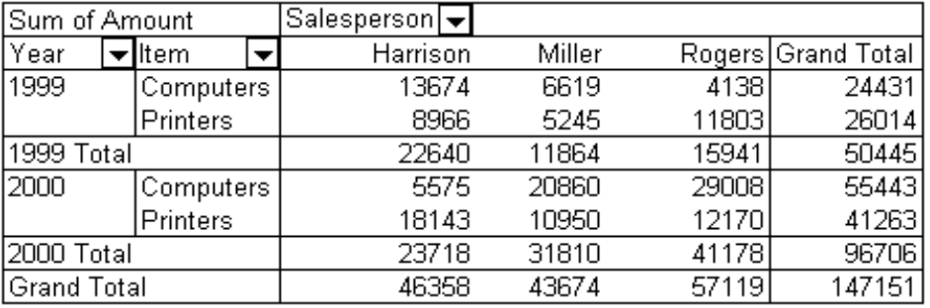
You should also see the PivotTable tool bar along with the PivotTable field list, as shown below:

Each field name is listed in the lower window. You can drag a field to the Pivot Table to be used for grouping or calculation purposes.
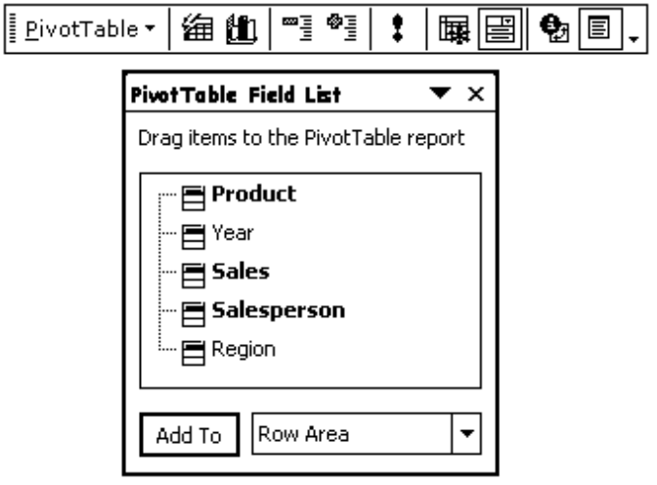

While working with Pivot Tables, the following tools are available:

Click on this tool to access a pull-down menu of options associated with the Pivot Table.

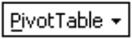

Click on this tool to access a dialog box where you can select from a variety of report formats.

This tool is used to create a PivotChart.


This tool is used to hide the detail data.


This tool is used to display the detail data.


This tool is used to refresh the pivot table after the source data has changed.


Click on this tool to include hidden items in the totals section.


Click on this tool to always display items.


After selecting a row or column field, this tool is used to change such settings as subtotals, sort and layout options.


Click on this tool to display or hide the field list.


NOTE: If you don’t see the PivotTable toolbar, point to a blank spot on any other tool bar and click the [RIGHT] mouse button once. From the list, choose PivotTable.


Some of the field buttons have pull-down lists that can be used to hide or show data contained within that field.

Clicking on the down arrow  beside a field will display a list of available entries for that field, as shown in the example below:

In this example, you would use the pull-down list to select which sales people should be included within the table.
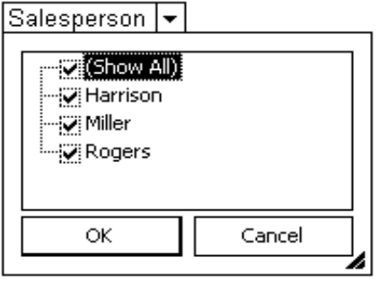

Check the names of each sales person to include in the table. Remove the check from any sales people you want excluded.

When done, click on to close the pull-down list. Both the pivot table and any linked pivot chart will be updated.

FORMATTING THE PIVOT TABLE

Once the pivot table has been created, you can change the format and layout of the table.

To do so, follow the steps outlined below:

❶ Click on the down arrow beside this tool to access a pull-down menu of options associated with the Pivot Table.

❷ From the pull-down list, select Format Report...
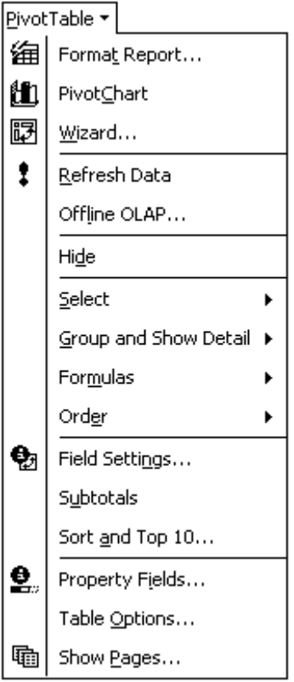
The following dialog box will be displayed:

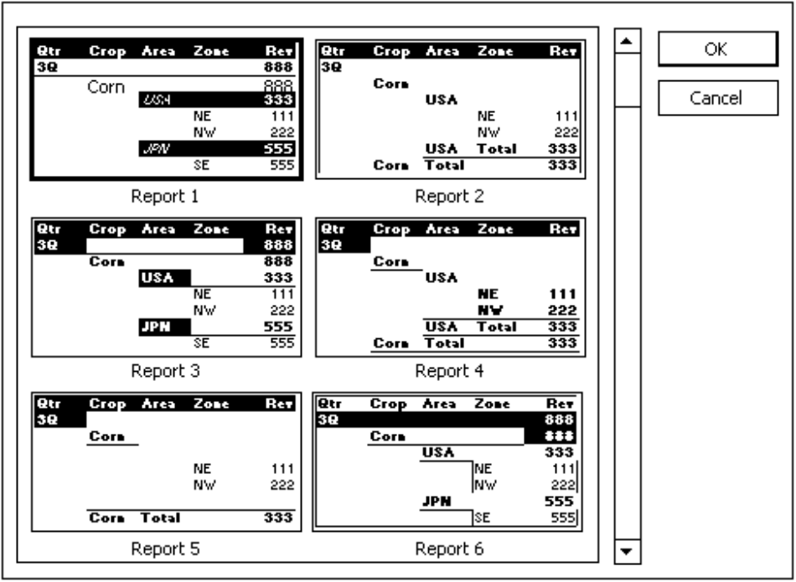

❸ From the list, select the desired format for the table.

❹ When done, click on .

PIVOT TABLE PAGES

If you have a large amount of data and would like to organize the information into multiple pivot tables, you can break the data down into pages. These pages are really nothing more than filters for the entire table. For example, if you have sales for both 1999 and 2000, you may wish to create a separate table for each year without having to define a second pivot table.

At the top of a pivot table is a section labeled “Drop Page Fields Here”. Drag the field to be used for the filtering the data (e.g., sales year) to this section. The field will have a pull-down list that shows all of the data or individual items. Simply select the item to be shown in the current table from the pull-down list.

To create separate pivot table pages for each item within the page field, follow the steps outlined below:

❶ Click on the down arrow beside this tool to access a pull-down menu of options associated with the Pivot Table.

❷ From the pull-down list, select Show pages...
A small dialog box will be displayed, asking you which field should be used for creating the pages:

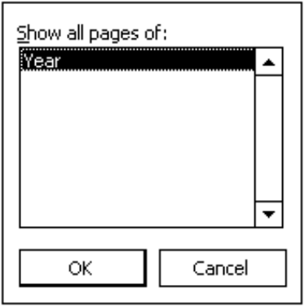
❸ Select the field to be used for creating the pages.

❹ When done, click on .

Excel will create a new worksheet for each data item within the selected field. Using the sheet tabs at the bottom of the document window, select the pivot table you wish to view.

REARRANGING THE DATA FIELDS

Although you can use the PivotTable wizard to reassign data fields, you can interactively work with the pivot table using your mouse and the tool bar.

To add a row or column field, drag the field from the tool bar onto the column or row section of the pivot table.

To create groups, drag additional fields to the left of the row section.

To remove a field, drag the unwanted field off the pivot table and release the mouse button.

WORKING WITH TOTALS

Unless you specify otherwise, Excel adds subtotal and grand total lines to the pivot table. Subtotals are the results of outer items of a pivot table consisting of more than one row or column field. Grand totals, on the other hand, are the results of all cells within the rows and columns of the table.

HIDING THE DETAILS FOR A FIELD

Since Excel automatically displays subtotals whenever a pivot table contains more than one row or column field and always displays a grand total, you may want to hide one or the other at some point. To do so, follow the steps outlined below:

❶ Select the field whose details you wish to hide.

❷ Click on this tool to hide the detail data for the currently selected field.


TIP: To hide the details for a single subtotal section instead of all subtotals, select the section whose details you wish to hide and then click on .

DISPLAYING THE DETAILS FOR A FIELD

If you have hidden the details for a field and have now decided that you need to view them again, follow the steps shown below:

❶ Select the field whose details you now wish to display.

❷ Click on this tool to display the detail data for the currently selected field.

CREATING A PIVOT CHART

Although you can create a pivot chart from scratch using the wizard, it is easier to create a pivot chart from an existing pivot table. Since pivot charts must be linked to a pivot table, you will end up creating a table anyway.

To create a pivot chart from an existing pivot table, follow the steps outlined below:

❶ Be sure the pivot table is active and the pivot tool bar is available.

❷ Click on this tool to create a pivot chart using the current table’s data.

Excel automatically creates a new sheet with the chart displayed, as shown in the diagram below:
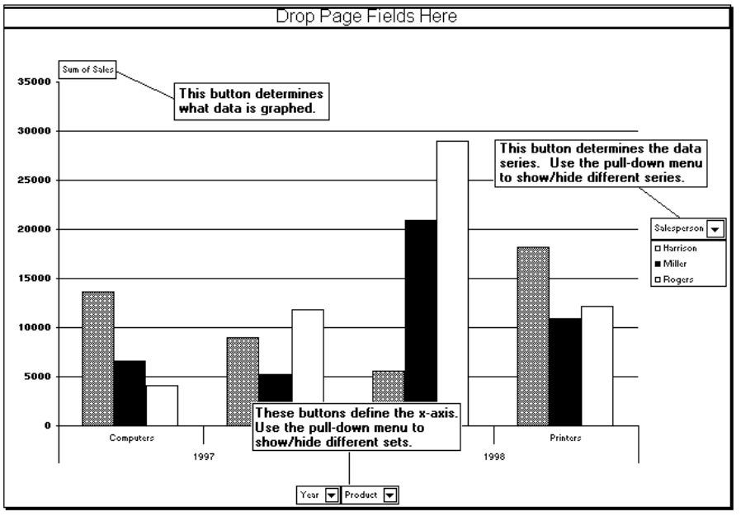

You can use most of the same formatting options (such as changing the bar patterns and colors) on a pivot chart as a on a standard chart. You will also notice that the chart contains field buttons similar to those on the pivot table. Use these buttons to interactively manipulate and reorganize the data on the chart - just as you would on the pivot table. In fact, any changes made to the chart will be reflected on the linked pivot table and vice-versa.

Some of the field buttons have pull-down lists that can be used to hide or show data contained within that field. For example, you might have noticed in the sample diagram on the previous page a field labeled “Salesperson”. This field was used for the data series and legends.

Clicking on the down arrow beside this field would display a list of available salespeople, as shown below:

In this case, you would use the pull-down list to select which salespeople should be plotted.

Check the names of each salesperson to include on the chart. Remove the check from any salespeople to be excluded.

When done, click on to close the pull-down list. Both the chart and pivot table will be updated with the new changes. As with the pivot table, you can also drag fields to different parts of the chart to create various perspectives of the data.

DISPLAYING/HIDING DATA FIELDS

Once you have the chart set up the way you want, you will probably want to hide the data field buttons before printing.
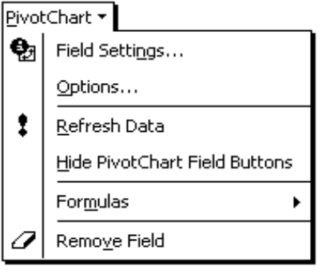

Click on the down arrow beside this tool (located on the PivotTable tool bar) and choose Hide PivotChart Field Buttons.
PRACTICE EXERCISE

Instructions: ❶ Open the SALEDATA.XLS workbook.

❷ Create a pivot table that shows the sales by year for the column and broken down by each salesperson for the rows.

❸ Once the table has been created, add the region as row subtotal. Rows should now be broken down by region first and each region is sub-divided by salesperson.

❹ Swap the year and salesperson fields so that the rows are broken down by year first and then by region while the columns show the salespeople.

❺ Hide the region details from the rows so that only the totals for each year are displayed. Do not delete the region field.

❻ Create a chart from the pivot table.

❼ Save and print/preview the file.



● The Goal Seeker
● The Scenario Manager
● Cell Comments
● Consolidating Data

USING THE GOAL SEEK

USAGE: The Goal Seek is used within Excel to create worksheets that have a final goal in mind but do not have the input to solve the problem. For example, if you were considering purchasing a new car and knew the maximum monthly payment amount you could make, it would be possible to use “Goal Seek” to determine what size loan you could afford. Basically, you are working backwards from an answer to determine the input values needed to achieve that answer.

Select the cell containing the final answer (i.e., the maximum monthly loan payment) and then access the following menu:
MENU:
tools
goal Seek...

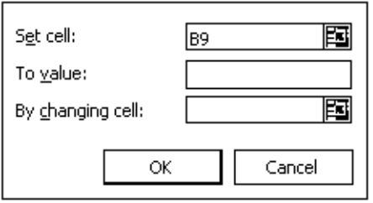
The following dialog box will be displayed:

The Set cell section should include the address of the cell containing the formula for which you want to find a solution. Click on to return to the worksheet to select the cell.

To value refers to the new value you are trying to reach (i.e., the monthly payment amount you could afford).

By changing cell refers to the address containing the value you want Excel to change to achieve the desired answer (i.e., the loan amount). Click on  to return to the worksheet to select the cell.

After making all of the necessary changes, select .
Depending on the complexity of the formula, you will see a dialog box showing Excel in action as it calculates the formula:
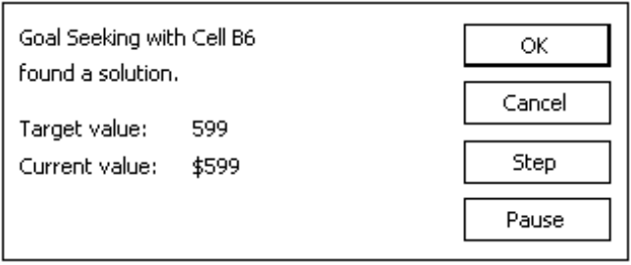

If Excel is working on a complex problem, you can click on the 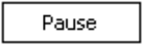 button to interrupt the calculation. You can then  through the calculations one at a time. To have Excel return to automatic calculation, choose to Continue.

To have Excel return to the original value, click on .

The example shown below illustrates how the goal seek feature would be accomplished:

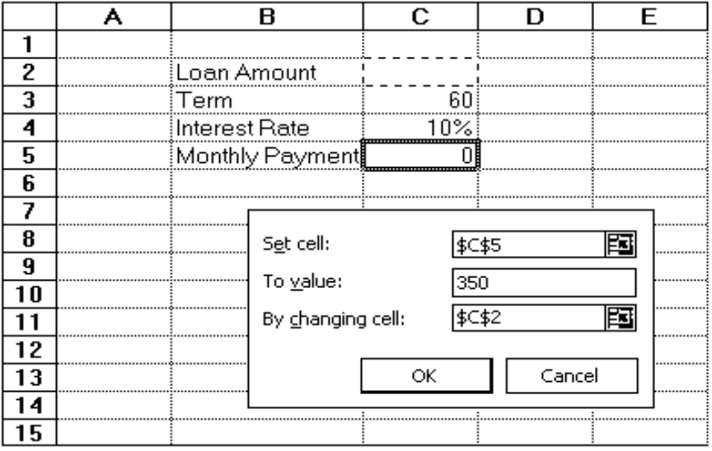

THE SCENARIO MANAGER

USAGE: Scenarios are sets of different data for the same block of cells. They are used to perform what-if calculations. For example, a worst-case scenario shows what value would result if the least desirable set of variables were placed in the model. On the other hand, a best-case scenario displays the value that would result if the most desirable set of variables were placed in the model. A most-likely scenario displays the value that would result if the most likely set of variables were placed in the model.

A scenario is simply a way of storing multiple sets of numbers that can quickly be recalled and displayed. This allows you to play “what if we looked at this scenario” type of games. You can easily select from a group of previously saved scenarios.

Each sheet in a workbook can have its own set of scenarios. For example, if you have a workbook with six worksheets (all with different products and sales statistics), you might want to construct a different scenario for each sheet. In each scenario, you can create models for best-case, worst-case and most-likely sales of each product.

Excel also can be used to create a pivot table report of your scenarios. The pivot table report lets you mix and match scenarios and then view the effects of these scenarios. This allows you to view a scenario with a different perspective.

CREATING A SCENARIO

To create a scenario, follow the steps outlined below:

❶ Create your spreadsheet with the first set of values that should be recorded as a scenario.

NOTE: Do not place formulas in the cells that are to be used for the changing values in the scenario.


❷ Access the following menu:
MENU:
tools
Scenarios...

The following dialog box will be displayed:
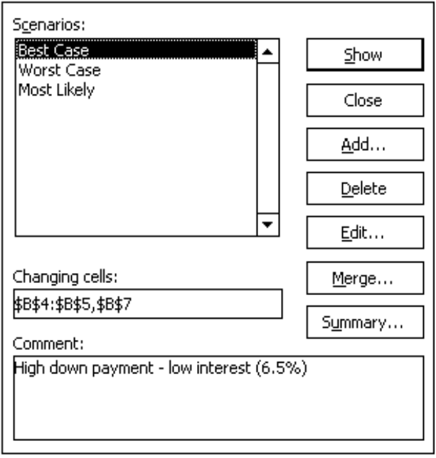

The box is divided into three sections:

Scenarios This section lists any existing scenarios.

Changing cells This box is used to define the cells that will change within the selected scenario.

Comment This section displays any comments for the selected scenario.
❸ Click on 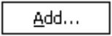 to define a new scenario. A second dialog box will be displayed, as shown below:
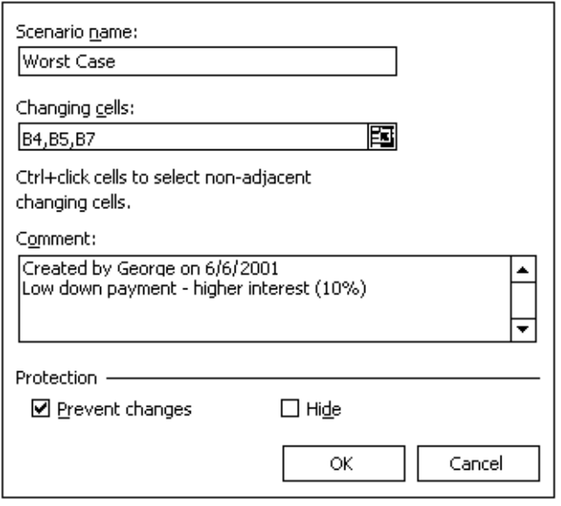

Scenario name Enter a name for the new scenario (up to 255 characters, including spaces).

Changing cells Click in this box to enter the changing cells for the new scenario. Click on the button to temporarily set aside this box and return to the worksheet where you can select the block by clicking and dragging within the worksheet. Re-activate the box by clicking on .

Comment Enter a comment for the new scenario. It will be displayed in the previous dialog box whenever this scenario is selected. By default, Excel adds a comment indicating who created the scenario.

Protection If the current worksheet has been protected, use these two checkboxes to prevent the scenarios from being modified or seen.

❹ Fill out this box and then click on .
Another box appears asking you to enter the values to be placed in the changing cells for the scenario you are creating:
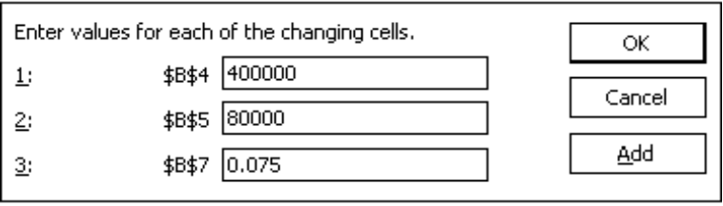

❺ Fill out this box and then click on . You will be returned to the original dialog box where the new scenario should have been added to the list of existing scenarios.

NOTE: If you click on the  button, Excel will take you back to the Add Scenario dialog box where you may add another scenario.


❻ From the original dialog box, click on  to close the dialog box and return to the worksheet.

DISPLAYING A SCENARIO

Once a scenario is defined, you can display it by accessing the following menu:
MENU:
tools
Scenarios...

The following dialog box will be displayed:

Double-click on the name of the scenario you wish to show.

When you select a scenario, Excel displays the values defined in the scenario in the changing cells of the worksheet - which should still be visible behind this dialog box.

Click on to return to the worksheet.

EDITING A SCENARIO

If you decide that an existing scenario needs to be edited, you can do so by accessing the following menu:
MENU:
tools
Scenarios...

The following dialog box will be displayed:

Highlight the scenario you wish to edit and click on .
A second box will be displayed, as shown below:
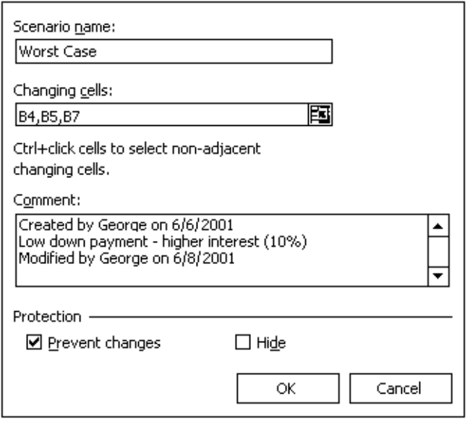

From within this second dialog box, make the necessary changes and then click on . A note will be added to the “Comment” box indicating a change has been made and by whom.

The next box appears allowing you to edit the values to be placed in the changing cells for the scenario you are editing:

Make any changes needed in this box and then click on . You will be returned to the original dialog box.

Click on to return to the worksheet.

MERGING SCENARIOS

If you have another worksheet with identical scenario models, you can merge them with the current scenario models. To do so, you will need to access the following menu:
MENU:
tools
Scenarios...

The following dialog box will be displayed:

Select the scenario you wish to merge and choose 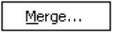.
A second box will be displayed, as shown below:

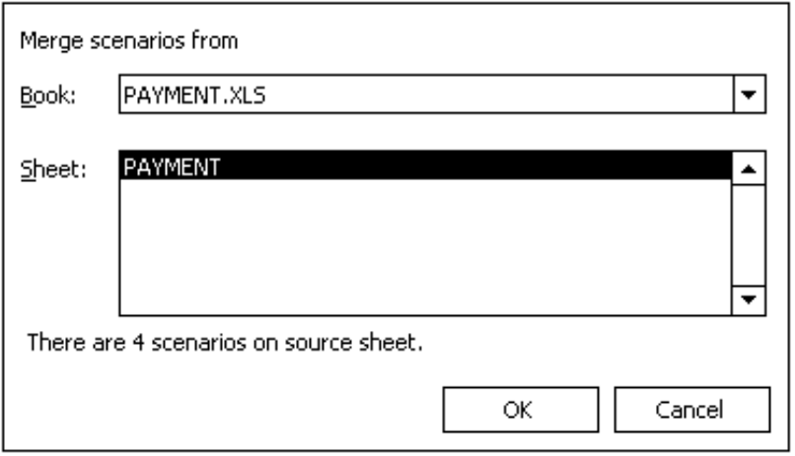
From within this second dialog box, select the file and worksheet containing the scenario models you would like to merge with the current one.

Once selected, click on .

You will be returned to the original dialog box where the merged scenario models will be listed along with those within the current worksheet.

Click on to return to the worksheet.

CREATING SCENARIO SUMMARY REPORTS

If you have multiple scenarios and would like to see a summary of them in one report rather than showing each scenario separately, you can have Excel create a summary report or a pivot table.

To do so, you will need to access the following menu:
MENU:
tools
Scenarios...

The following dialog box will be displayed:

Select the scenario you wish to create a summary report for and then choose .
A second box will be displayed, as shown below:

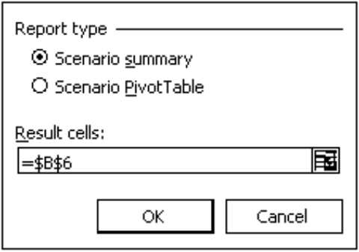
From within this second dialog box, select the type of report you would like Excel to create.

Click in the box labeled Result cells to select the cell(s) whose values will be changed as a result of your input cells. For example, if your scenario changes the loan amount and interest rate, you would want to see the resulting monthly payment for each scenario.

Click on the button to temporarily set aside this box and return to the worksheet where you can select the block by clicking and dragging within the worksheet. To re-activate the box, click on .

When done, click on . You will be taken to a new worksheet where the summary report has been created, as illustrated in the example shown below:

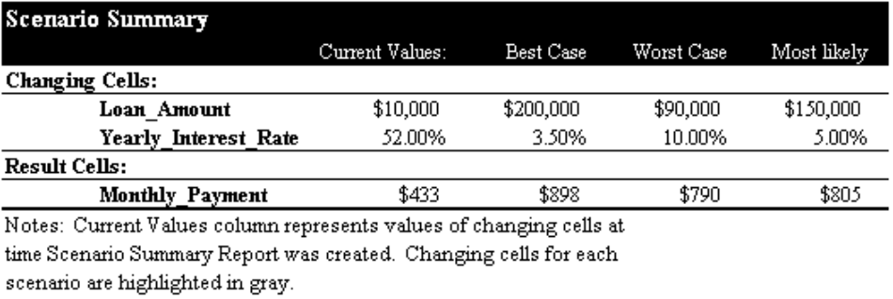

DELETING A SCENARIO

If you no longer want one of your scenarios, you will delete it. To do so, access the following menu:
MENU:
tools
Scenarios...

The following dialog box will be displayed:

Select the scenario you wish to remove and choose . You will not be asked to confirm the deletion of the scenario.

When done, choose .

ADDING CELL COMMENTS

USAGE: You can attach comments to cells so that you may later understand why a formula or entry was placed within a cell. These comments are not typically printed with the worksheet - unless you instruct Excel to do so.

To add a cell comment, follow the steps outlined below:

❶ Select the cell you want to add a comment to.

❷ Access the following menu:
MENU:
insert
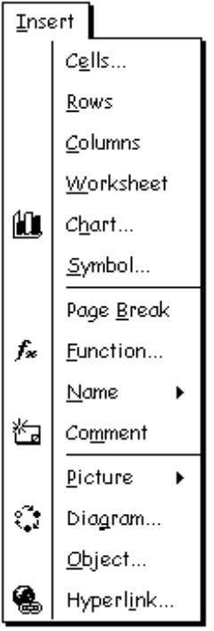
Comment

A yellow post-it type of window appears, as shown below:
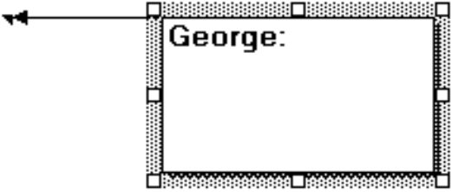

❸ You may now enter your comment. It may be as long as you need. Excel will automatically wrap the note from line to line within the box.

❹ When done, click away from the box.

NOTE: A small red triangle in the upper right corner of a cell indicates a comment exists for that cell. When you move your mouse over the cell containing the comment, the comment will be displayed. If a sound clip has been added, it will automatically be played.

REPOSITIONING/SIZING THE COMMENT BOX

You can easily change the position or size of a comment box by clicking and dragging the box to a new location or dragging one of the handles to change its size.

The repositioning of a comment box can come in handy to place it off to the side so it does not overlap existing cells. An arrow will point to the original cell that the comment is stored in.

To display the Reviewing tool bar, point to any other tool bar on your screen and click your [RIGHT] mouse button once. From the list of available tool bars, select “Reviewing”.

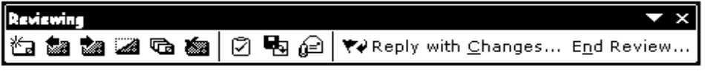

The first six tools affect comments, as discussed below:

This tool either inserts a new comment (if you have selected a cell without a comment) or edits the current comment (if one has been attached to this cell).



Click on this tool to view the previous comment.


Click on this tool to view the next comment.

This tool is used to continuously display the current comment - even when you move away from the cell.


This tool is used to display all comments within the worksheet.


This tool deletes the current comment.


EDITING A COMMENT

To edit an existing comment, follow the steps outlined below:

❶ Select the cell containing the comment you wish to edit.

❷ Click on this tool to edit the comment.

❸ Make the necessary changes.

❹ When done, click away from the comment box.

DELETING A COMMENT

To remove an unwanted comment, follow the steps outlined below:

❶ Select the cell containing the comment you wish to remove.

❷ Click on this tool to delete the comment. You will not be asked to confirm the removal of the comment.

ADDING AN OUTLOOK TASK

USAGE: If you are in the middle of working on a complex workbook and decide that you need to move on but want to remind yourself (or another user who may also have access to the workbook) to complete the file at a later time, you can assign a task to the workbook. Although you could create a cell comment, a task might be a better option. If you simply add a cell comment but do not reopen the workbook for awhile, you might forget about the portion of the file you need to complete. However, if you assign a task to the workbook, you can be reminded of the task anytime Outlook is running on your system.

To assign a task to a workbook, follow the steps outlined below:

❶ Display the Reviewing tool bar by pointing to any other tool bar on your screen and clicking your [RIGHT] mouse button once. From the list of available tool bars, select “Reviewing”.

❷ Click on this tool to assign a new task.


The following dialog box will be displayed:

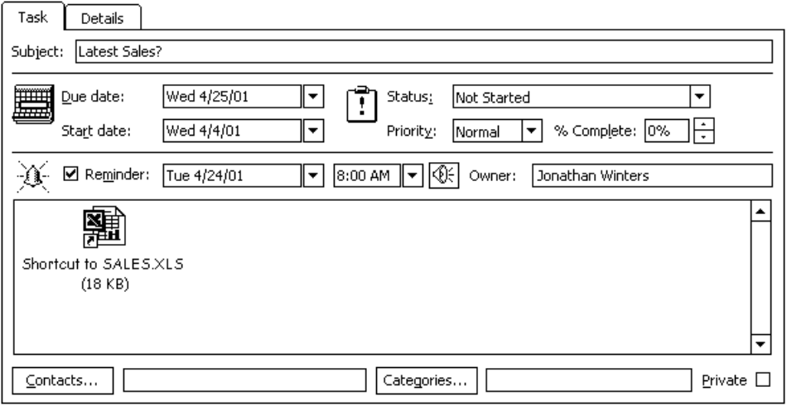
❸ Be sure to select the Task tab from the top of the dialog box.

❹ Click in the Subject box to enter a name for the new task.

❺ Select a Due date for the new task.

❻ Select a Start date for the task.

❼ Add any comments or description in the box provided at the bottom of the dialog box.

The following optional items are also available within this box:

Status Click on the down arrow beside this option to select the status of the task.

Priority Click on the down arrow beside this item to specify the task’s importance.

Complete Enter the % Complete in the box provided or use the up/down arrows to increase/decrease the entry.

Reminder Check the Reminder box to be reminded of the task.

Click on this button to associate/link the new task to any contacts within your Address Book.


Click on this button to associate/link the new task to any categories.
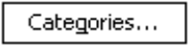

Private Check this box to hide this item from other users who might have access to your calendar.

❽ When done, click .

Depending on what reminder you set, you will receive notifications from Outlook prompting you to complete the task you just created.

WORKING WITH SHARED FILES

USAGE: If you have a large workbook and would like other users to be able to have access to it simultaneously, you can choose to “share” the file. This can be useful if several users need to make modifications to the same file. Shared workbooks can be stored on a local network (intranet) or over an Internet location.

SHARING A WORKBOOK

To share a workbook with other users, you will need to follow the steps outlined below:

❶ Open the file you wish to share.

❷ Once the file has been opened, access the following menu:
MENU:
tools
Share Workbook...

❸ Select the tab labeled Editing, as shown below:
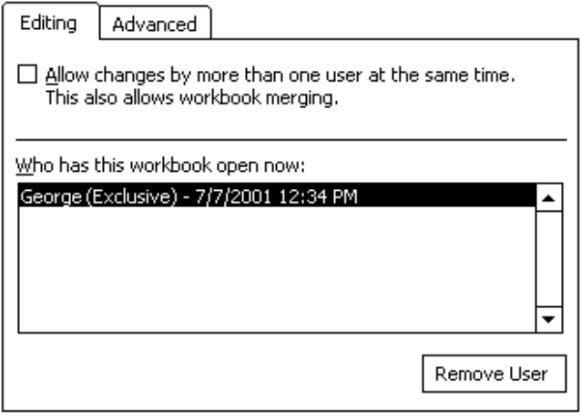

If the workbook is already being shared with other users, Excel will list who has this workbook open now in the middle of the dialog box. To remove an unwanted user from sharing this file, select their name from the list and then click on the 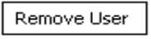 button.

NOTE: Each user name is obtained by Excel in the Tools → Options menu under the tab labeled General.

❹ Check the box labeled Allow changes by more than one user at the same time.

❺ To set specific sharing options, select the Advanced tab.
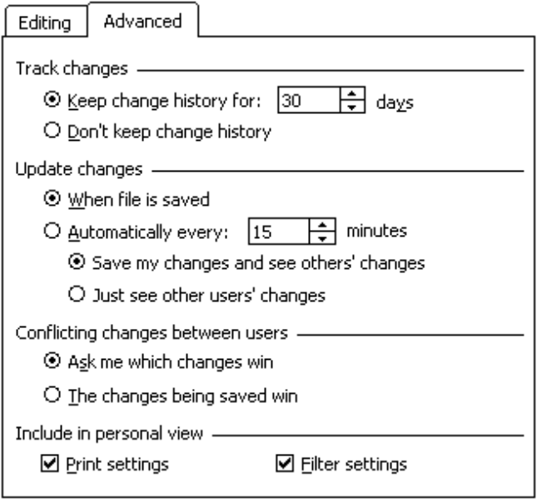

This dialog box is divided into the following sections:

Track changes Use this section to specify whether Excel should maintain a history of the changes made to the shared workbook and, if so, for how many days. Maintaining the history can be useful for tracking changes made by individual users and for restoring original entries in case of errors.
Update changes Use this section to specify when updates should occur (only when the file is saved or automatically after a specified amount of time).

Conflicting changes This section is used to determine which
between users changes have priority when they are in conflict with another user. You can choose to be asked which changes should be made or automatically allow the changes being saved to override others.

Include in personal view This section contains two checkboxes. The first one (when checked) is used to save your personal print settings in the shared workbook for others to access. The second box (when checked) saves any filters you may have set in the shared workbook for other users to access along with the file.

❻ Select the share options you wish to set.

❼ When done, click on .

Other users may now open the workbook as they would any other file. However, the word Shared will be added to the title bar - indicating that the file is now being shared.

UPDATING A SHARED WORKBOOK

If you are working on a shared workbook, you should periodically update your version to ensure you are seeing the latest changes from anyone else who may be working on the same workbook. This way you can see if any changes you are about to make will conflict or override another user’s changes.

To update a shared workbook, follow the steps outlined below:

❶ Display the Reviewing tool bar by pointing to any other tool bar on your screen and clicking your [RIGHT] mouse button once. From the list of available tool bars, select “Reviewing”.

❷ Click on this tool to update the original workbook to reflect the changes other users (who may be sharing this file) have made.


The workbook will now reflect the latest changes made by other users who are sharing the same workbook.

REVIEWING WORKBOOKS

USAGE: If you would like to have several people review a workbook and possibly make changes to it, you can choose to route the file to multiple mail recipients.

Once a reviewer has finished his or her modifications, they will then e-mail the changes back to the original sender.

REQUESTING A REVIEW

To request that the current workbook be reviewed by one or more mail recipients, follow the steps outlined below:

❶ Open the workbook you want to be reviewed by other users.

❷ Access the Tools → Share Workbook menu to share it.

❸ Once shared, access the following menu:
MENU:
file
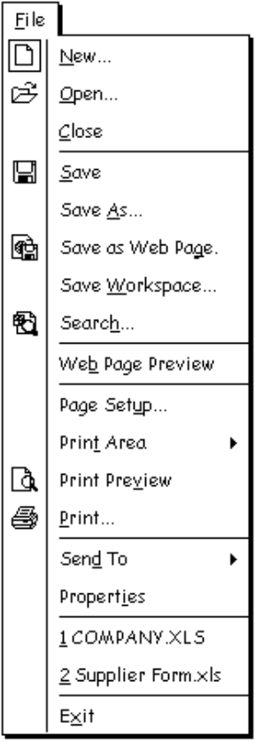
Send To ➢

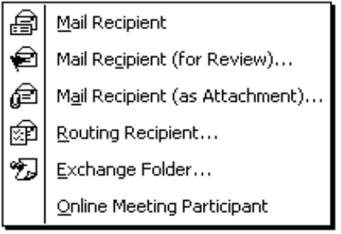
Select Mail Recipient (for Review)...
The Outlook “New Message” screen will be displayed:

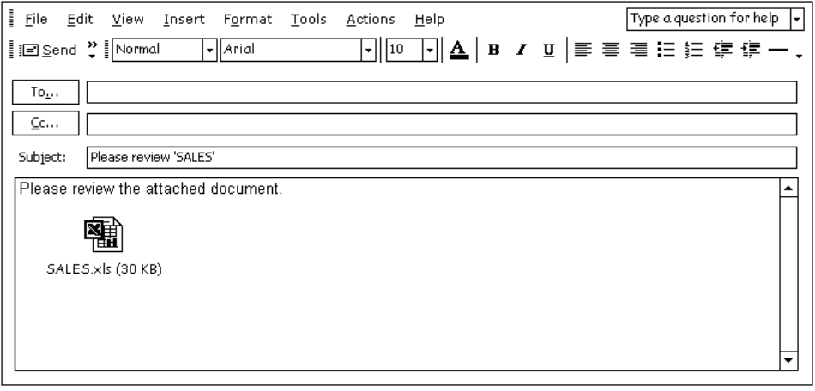
❹ Click in the To: section and enter the address(es) you wish to send the workbook to for review.

If you are unsure of the spelling, click on this button and choose from a list of stored addresses.


(OPTIONAL) ❺ Although Excel has automatically created a subject, you can click in the Subject: section and enter a new one.

❻ Click in the Contents area and begin typing any text to accompany the file you are asking the recipient(s) to review.

❼ Click on this button to send the message to your Outbox. Outlook will periodically check for new mail and send messages stored in your Outbox.


(OPTIONAL) ❽ If you wish to send the message immediately, click on this button (from within Outlook) to send the message now and to check for any new mail that may have been received.
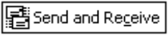

REPLYING TO A REVIEW REQUEST

If you are using Outlook and receive a request to review a workbook, open the file as you would any other attachment.

Outlook should recognize the file format of the attachment as an Excel workbook and will automatically start Excel and open the file. Once opened, you can begin making any changes and adding comments you feel are necessary to the workbook and then follow the steps outlined below to send those changes/comments back:

❶ Display the Reviewing tool bar by pointing to any other tool bar and clicking your [RIGHT] mouse button once. From the list of available tool bars, select “Reviewing”.

❷ Click on this tool to reply to the original review request message.


❸ Since you are simply replying to the original message, the recipient and subject information have already been filled in. To add any comments, click in the Contents section.
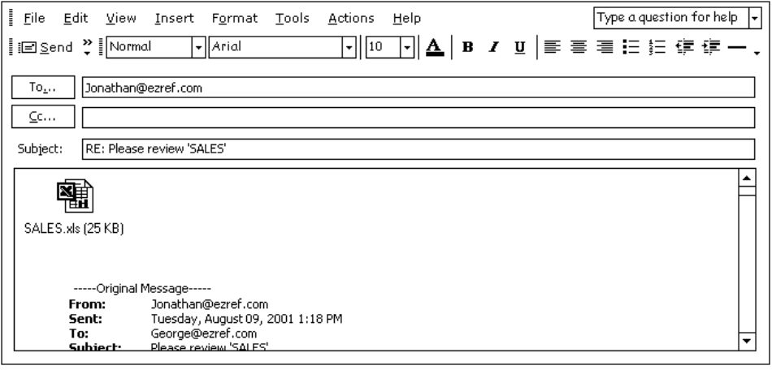

❹ Click on this button to send the reply with the reviewed workbook as an attachment.

MERGING REVIEWED WORKBOOKS

Once all reviewers have replied with their editing changes and comments for the shared workbook, you can merge these changes with the original file. To do so, follow the steps outlined below:

❶ From within Outlook, open the e-mail reply message containing the reviewed workbook and open the attached workbook file.

As Excel begins to open the attachment, the following message box will be displayed, asking if you want to merge the reviewed changes with the original file:
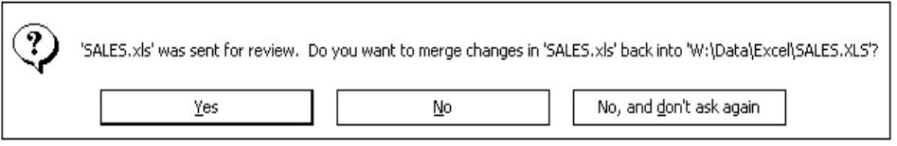

❷ Click on 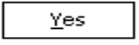 to merge the changes. You should immediately see some changes (colors and formatting modifications). However, changes to actual data may not be quite as apparent but will be flagged with a comment.

❸ The next step is to review the changes and accept or reject each one by accessing the following menu:

MENU:
tools
track Changes ➢

Select accept or Reject Changes...
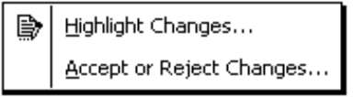
The following dialog box will be displayed:
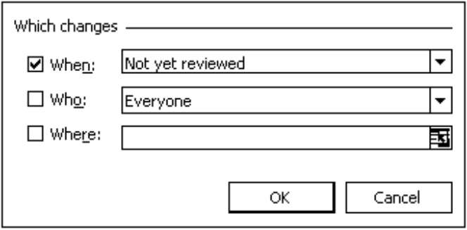

When Use this section of the dialog box to review the changes made since a specific date or to check for any changes not yet reviewed. Unless you have previously reviewed the changes, keep the default setting as it is.

Who Select which user’s changes you wish to review. You can choose to review changes made by everyone, everyone but you, or an individual user.

Where Use this box to specify the spreadsheet location to review. Click on to return to the spreadsheet and highlight the block of cells to be reviewed. The dialog box will be collapsed. After selecting the block to review, click on  to expand the dialog box.

If you leave this box blank, Excel will include the entire workbook.

❹ Using the three options within this dialog box, set your criteria for reviewing the changes made to the current workbook.

❺ When done, click on .

A second dialog box will be displayed, as shown below:

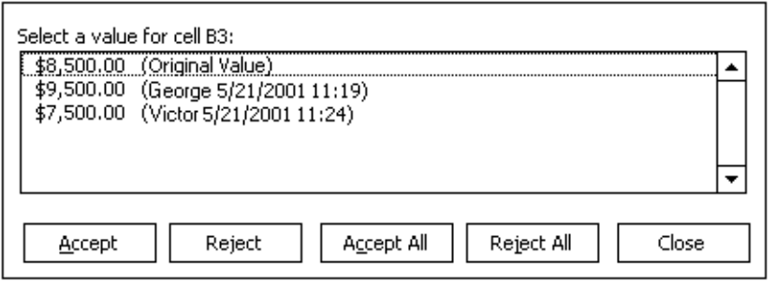
❻ Excel will display the original value for the first changed cell as well as the modified data. Select which value you wish to accept for this cell.

The following buttons are available within this second dialog box:

Click on this button to accept the selected change. Once a change has been accepted, it becomes part of the file and is no longer marked.
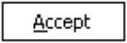

Click on this button to reject the displayed change and return the cell to its original value.
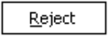

Click on this button to accept all remaining changes. If a cell has more than one value changed, the most recent value will be accepted.


Click on this button to reject all remaining changes and return the cells to their original values.


Click on this button to undo the last action.
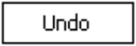

Click on this button to close the dialog box.
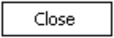

❼ Continue accepting/rejecting the changes as desired. When done, close this dialog box and save the file.

ENDING THE REVIEW PROCESS

Once you have received all of the reviewed workbooks and have merged the changes into the original file, you can end the review process which will clear any remaining changes from the history of the workbook and will remove the shared status from the file.

To end the review process, follow the steps outlined below:

❶ Display the Reviewing tool bar by pointing to any other tool bar on your screen and clicking your [RIGHT] mouse button once. From the list of available tool bars, select “Reviewing”.

❷ Click on this tool to end the review process.


You will be asked if you are sure you want to end the review:
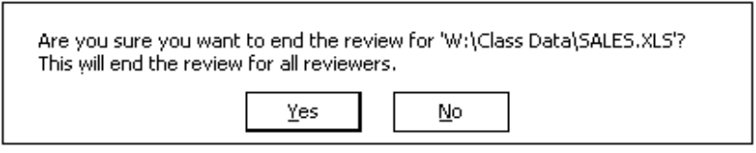

❸ Click on to continue.
Next, you will be asked if you want to clear the history and remove this workbook from shared use, as shown below:

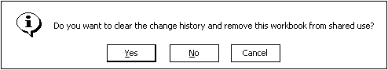
❹ Click on to continue.

The last box provides a final chance to keep the shared status and the change history:
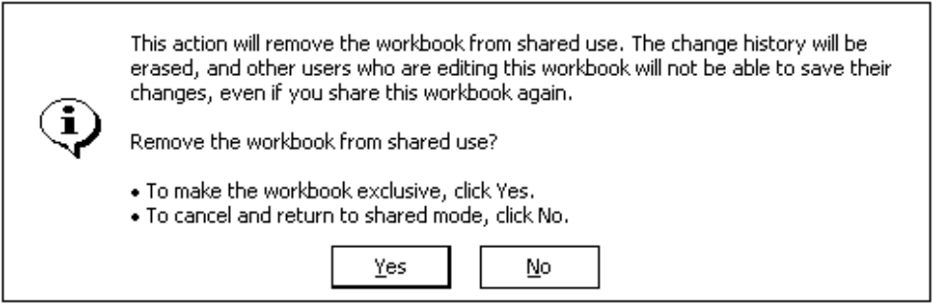

❺ Click on to end the review process.

The workbook will now be in exclusive mode (not shared with other users) and all of the changes that were previously merged from other reviewers will be cleared - except those you have already accepted.

SENDING A WORKBOOK TO ANOTHER USER

USAGE: If you are in the middle of working on a workbook and decide that you need to e-mail a copy of it to another user, you can send the file as an attachment to a mail message. This will send an exact copy of the workbook to a mail recipient.

To mail a copy of the current workbook to another user, follow the steps outlined below:

❶ Display the Reviewing tool bar by pointing to any other tool bar on your screen and clicking your [RIGHT] mouse button once. From the list of available tool bars, select “Reviewing”.

❷ Click on this tool to attach the current workbook to a new e-mail message.


Outlook will be opened and a “New Message” screen will appear:

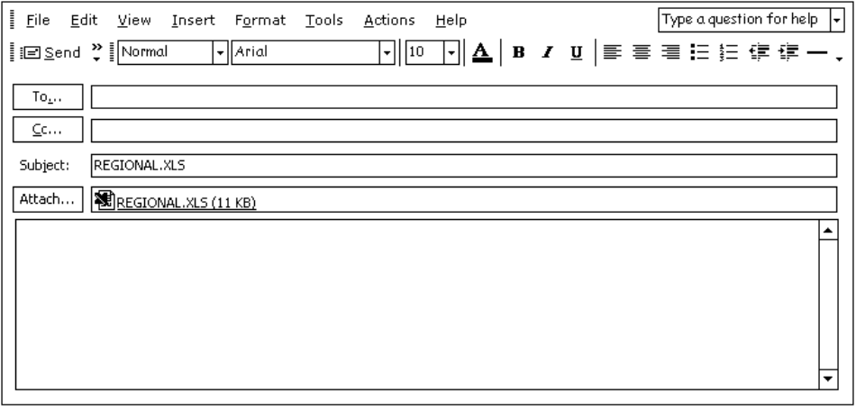
Notice that Outlook has filled in the subject of the new message with the name of the current workbook and has automatically attached the file to the message.
❸ Click in the To: section and enter the address you wish to send the new message to.

If you are unsure of the spelling, click on this button and choose from a list of stored addresses.
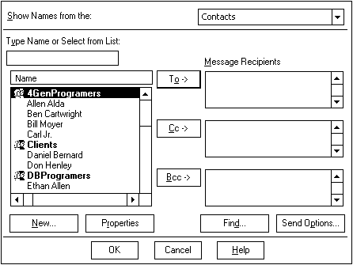

SELECTING MULTIPLE ADDRESSES

To select contiguous addresses, move to the first address and click once. Move the mouse to the last address to select and hold the S key down as you click once.

To select noncontiguous addresses, hold the C key down as you click on each address to be included.

CHOOSING THE ADDRESSEE DESIGNATION

Select whether the message is being sent (the main recipient), as a (a courtesy copy is being furnished to another user) or as a (blind courtesy copy).
When done selecting an address, choose to close the Address Book. You will be returned to the “New Message” window.

(OPTIONAL) ❹ If you would like to enter a different subject for the new message, click in the Subject: section and enter a brief description. This is important as the recipient will see this subject in their Inbox as a header explaining what the message deals with.

❺ Click in the Contents area and begin typing any text you would like to accompany the attached file.

❻ Click on this button to send the message to your Outbox. Outlook will periodically check for new mail and send messages stored in your Outbox.

(OPTIONAL) ❼ If you wish to send the message immediately, click on this button (from within Outlook) to send the message now and to check for any new mail that may have been received.

CONSOLIDATING DATA

USAGE: The Consolidate command is used to do exactly what its name implies - to consolidate information from many sources (up to 255) into one. For example, if you were interested in obtaining statistical data from various offices across the country so that you could create a workbook based solely on their totals, you could use the consolidate command to combine the individual office totals into one grand total.

You may also add a link between the consolidated workbook and its supporting files so that any time a change is made to one of the supporting worksheets, the consolidated file is automatically updated to reflect that change.

When you instruct Excel to consolidate, you will be asked whether to consolidate by position or by category.

If you choose to consolidate by position, Excel combines the data from the same cell address in each of the supporting worksheets. This means that the data you want consolidated must be in the same cell in each workbook.

However, if you choose to consolidate by category, you can have the data in different cell addresses. Excel simply consolidates the information based on common category headings, no matter what column or row they are located in.

NOTE: When consolidating by category, Excel does not care what column the source data is stored in. However, the category labels must be located either in the first row or in the leftmost column of the source range.

Before continuing, be sure you are in the workbook you want to contain the consolidated information. Although it is not mandatory, if possible, have all of the supporting workbooks open in memory.
Select the block of cells to contain the consolidated data and then access the following menu:
MENU:
data
Consolidate...

The following dialog box will be displayed:
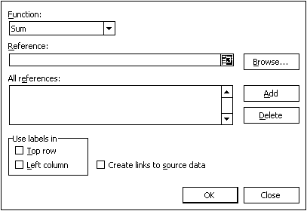

Function You will need to specify which mathematical function is required for the consolidation. The default is the SUM function. Click on the down arrow beside the currently selected function in this section to choose a different one.

Use labels in There are two checkboxes in the bottom left corner which are used when consolidating by category. Simply check whether the headings (labels) are located in the top Row of each worksheet or in the left Column.

If you are consolidating by position, leave both boxes blank (without checkmarks).
Reference You must now instruct Excel as to which block of cells are to be consolidated. Either type the source block in the Reference box or use the mouse to point to each block. If you click on the button, the box will be temporarily set aside and you will be taken back to the worksheet where you can select the range. Once the range has been selected, re-activate the dialog box clicking on the button.

After each reference, click on .

If you type in the cell references, you must include the full filename, as shown in the example below:

COMPANY.XLS!A1:A50

If you want to use the mouse to highlight the blocks of cells to consolidate, use the window menu or the taskbar to select the workbook containing the data cells.

Highlight the cells containing the data to be consolidated and then click on the button. Continue this for each workbook to be consolidated.

At the bottom of the dialog box you will see a checkbox which is used to Create links to source data. If you choose this option, Excel will create a link to each cell being consolidated so that changes in the worksheets will automatically be updated in the main worksheet.

After making the necessary selections, choose .
PRACTICE EXERCISE

Instructions: ❶ Open the following workbook files:

COMPANY FY1996 FY1997
FY1998 FY1999 FY2000

❷ In the Company file, highlight cells B5 through E15.

❸ Consolidate the data from the worksheets FY1996 through FY2000 into this worksheet.

❹ Add a cell note to cell A2 that has the following text:

Files used to consolidate this worksheet include:

FY1996.XLS
FY1997.XLS
FY1998.XLS
FY1999.XLS
FY2000.XLS

